# **How to Buy a WSDOT Ferry Ticket**

WSDOT operates ferries to several destinations. Use this step-by-step guide to learn how to buy your ferry ticket.

1. Go to <https://www.wsdot.wa.gov/ferries/>

*Tip: Before you begin, review the links on the home page under* ***PLANNING A TRIP*** *for information about vehicle reservations and current fares, and the information under* ***TRAVEL CONDITIONS*** *to see up-to-date alert bulletins. This information will help you prepare for your trip.*

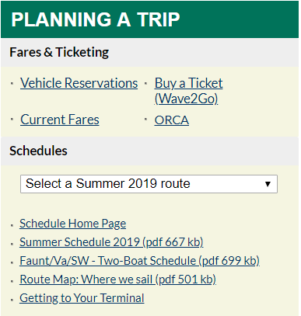2. On the home page under **PLANNING A TRIP**, select your route from the dropdown menu to see when the ferry is traveling to your destination, or click **Buy a ticket (Wave2Go)** if you are ready to buy your ticket. You will then be directed to the Wave2Go Online Ticket Purchasing page.

View ferry schedules and begin your purchase

*Note: If you plan to bring your vehicle, you should be in line 20 minutes prior to the scheduled departure time.*

*Tip: On the Wave2Go Online Ticket Purchasing page under the* ***Most Requested*** *section on the left, click on* ***Find Your Terminal*** *and select your departure terminal to see the terminal address, current wait times, number of available parking spots, and a live video feed.*

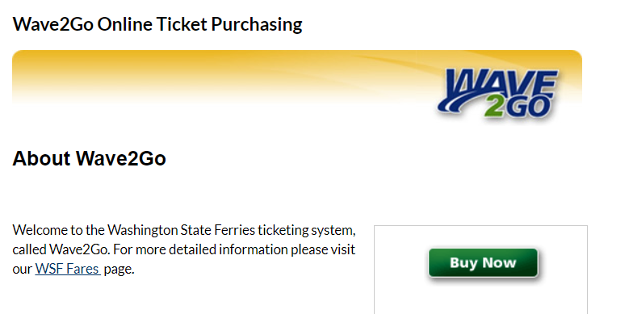3. Click **Buy Now** and select your route from the list on the left side of the webpage.

Click **Buy Now** to purchase your tickets

*Note: For most routes, tickets are round trip, good for 90 days, and are non-refundable. Vehicle tickets are purchased each way.*

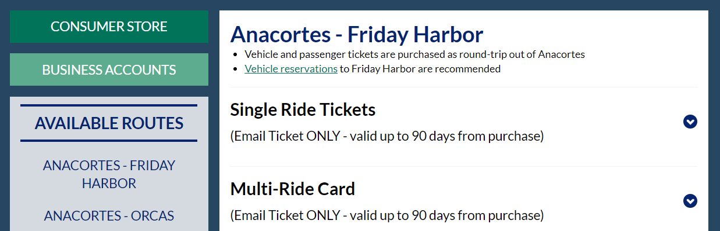4. Under the **Available Routes** section on the left side of the webpage, select the route for which you would like to buy tickets and click on the type of ticket you want to buy. The image below uses the Anacortes – Friday Harbor ferry as an example.

Select your route

5. Enter the information requested for all fields that apply to your trip, such as the number of passengers and vehicle information. Click **Add to Cart** and **Checkout** on the next page to purchase your tickets.

*Note: Your tickets will be emailed to you in PDF format.*

6. Create an account or checkout as a guest to buy your ticket. Print off your ticket and present it to the attendant when you arrive at the terminal, and you’re ready for your trip on the Washington State ferry!

*Related Links: Please refer to* [*http://www.wsdot.wa.gov/ferries/*](http://www.wsdot.wa.gov/ferries/) *or call 1-888-808-7977 for more information.*